**Energy Audit for Households**

**The Idea:**

The solution we propose for the hack statement is as follows:

* We have a web application via which the user is able to create his profile and upload his monthly consumption bills.
* We have our machine learning model (XGBRegressor and KNNClassifier) running on that data, which given the mains reading would be able to predict each appliance’s contribution towards the monthly consumption bills.
* All the results will be plotted so that the user can easily identify the usage statistics.
* We’ll also have a bucketing algorithm which will tell the user over the course of his consumption database created the top 25 appliances being most frequently used, thereby helping him to monitor the usage of the concerned appliances.

**Flowchart**

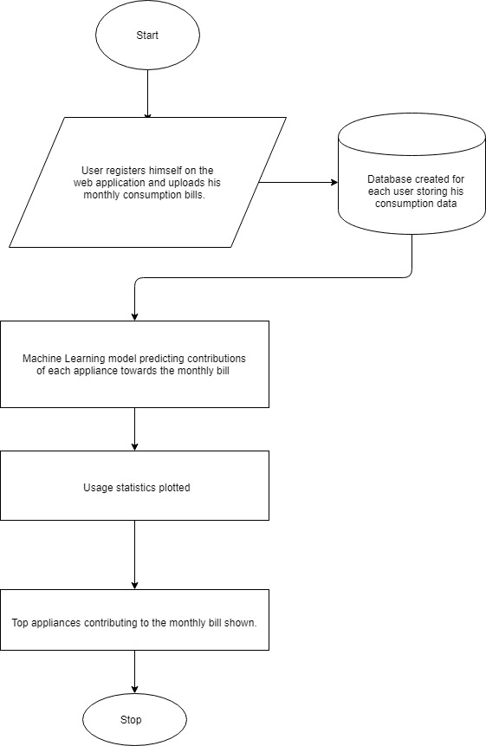

**Scope of Work to be implemented:**

* Web application for the user to register himself and upload his monthly consumption bills
* Machine Learning model to run on the data giving us the predictions and usage statistics
* Bucketing algorithm to display the top 25 appliances used most commonly.